### ****Objectives****

* Understand the limitations of the **Waterfall project management model** in data projects.
* Learn how **Agile methodologies** (Scrum, Kanban) improve data project outcomes.
* Explore the integration of **Lean and Six Sigma principles** for process optimization.
* Understand **key roles in Agile Scrum**, such as **Scrum Master** and **Product Owner**.
* Learn how to apply **iterative development, collaboration, and adaptability** in data-driven initiatives.
* Gain insights into **stakeholder engagement** and aligning data projects with business objectives.
* Review real-world case studies and best practices for implementing Agile in **data engineering**.

### ****Key Concepts****

#### ****1. Challenges of Traditional Waterfall Project Management****

* **Rigid and linear approach**: Sequential steps (requirements → design → development → testing → deployment).
* **Limited adaptability**: Difficult to accommodate evolving project needs.
* **Delayed feedback cycles**: Stakeholder input often arrives too late.
* **Complexity in data projects**: Inflexible models struggle with **unstructured data, real-time changes**, and **continuous integration**.

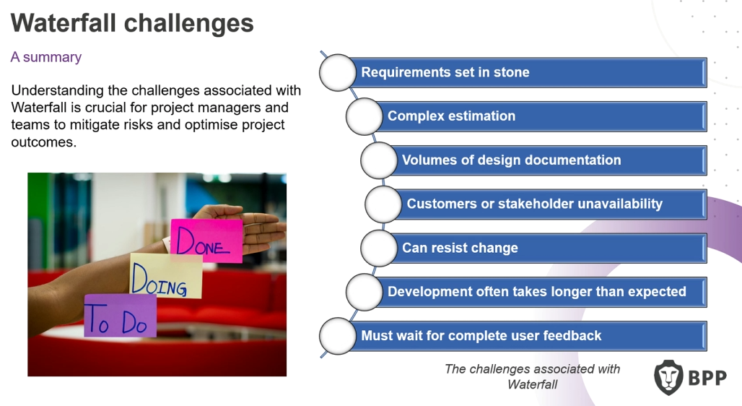

#### ****2. Agile Methodologies in Data Projects****

* **Agile core values**:
  + **Adaptability**: Responding quickly to changes.
  + **Iterative development**: Breaking work into smaller cycles (sprints).
  + **Collaboration**: Engaging stakeholders early and frequently.
  + **Delivering incremental value**: Ensuring continuous improvements.
* **Scrum vs. Kanban**:
  + **Scrum**: Structured sprints (1-4 weeks), with roles like **Scrum Master** and **Product Owner**.
  + **Kanban**: Focuses on **visual workflow**, limiting work in progress to avoid bottlenecks.

#### ****3. Key Roles in Agile Scrum****

* **Scrum Master**: Facilitates Agile processes, removes blockers, ensures collaboration.
* **Product Owner**: Manages backlog, prioritizes work, and aligns project goals with business needs.
* **Development Team**: Engineers, analysts, and stakeholders working collaboratively.

#### ****4. Agile Practices in Data Engineering****

* **User Stories & Sprint Planning**: Define tasks, estimate efforts (e.g., using **Story Points**).
* **Sprint Reviews & Retrospectives**:
  + **Sprint Review**: Demonstrating completed work to stakeholders.
  + **Sprint Retrospective**: Reflecting on processes to improve efficiency.
* **Backlog Grooming**: Continuous refinement of task priorities to prevent scope creep.
* **Burn-down Charts**: Visual tracking of sprint progress.

#### ****5. Lean & Six Sigma in Data Projects****

* **Lean**: Eliminating waste, focusing on value-driven workflows.
* **Six Sigma**: Improving data quality and reducing errors using **DMAIC** (Define, Measure, Analyze, Improve, Control).

### ****Questions****

1. How can Agile principles be adapted for **large-scale data projects** that involve long processing times?
2. What are the **best practices for managing data complexity** within Agile sprints?
3. How can companies **balance Waterfall and Agile** in hybrid project management approaches?
4. What **tools and frameworks** are recommended for implementing **Scrum and Kanban** in data engineering teams?
5. How can we measure the **success of Agile adoption** in a data-driven organization?
6. What are the biggest **challenges in transitioning** from traditional project management to Agile for data teams?

